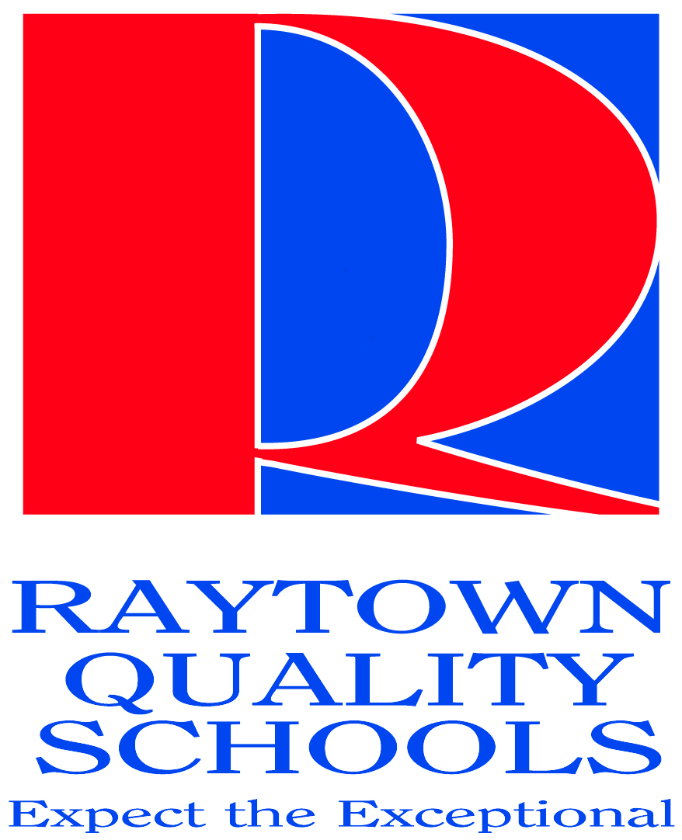

Board of Education
2011-2012 Goals

Based upon the guiding principle that we put children first in all we do,
the Raytown Quality Schools Board of Education hereby
adopts the following goals for the 2011-2012 school year:

1. Increase student performance to achieve an Annual Performance Report rating of 12 out of 14 for the 2011-2012 school year, while placing an emphasis on continuous improvement to ultimately achieve the Distinction in Performance Award from the Department of Elementary and Secondary Education.

2. Ensure that the school community is welcomed and valued as an integral part of our district by engaging them in a broad range of district decision-making activities in a safe and comforting environment.

3. Establish hiring guidelines and best practices to attract and retain staff for an effective, high quality educational environment.

4. Achieve a minimum of 10 percent minority new hires for the Raytown Quality Schools staff for the 2012-2013 school year.

5. Provide salary and compensation package for effective staff that is within the upper 50 percent of the districts in the metropolitan area.

6. Assure that all children and staff are in a safe environment through the continued maintenance and review of the district’s crisis/disaster plans and the continued cooperation of various outside agencies.

7. Establish a long-range technology plan for effective classroom delivery including the use of virtual technology and social networking.
8. Determine the feasibility of implementing a mandatory community service component to graduation requirements in a manner that is permissible under Missouri state law.

